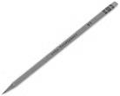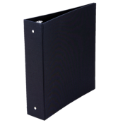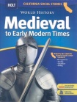

* Remind updates- **Text 81919 with the message @h4ded**
* Aeries Gradebook
* Class Web Site - <http://mrsamadorsclass.weebly.com/>

Policies

* Tardy if you’re not in seat when bell rings
* No phones or food in class unless approved by teacher
* Bathroom breaks will deduct points off participation grade
* Discipline will be handled using the school’s 3 step referral process
* Respect everyone and everything
* Always do your best!

but not necessary, supplies include color pencils, markers, glue, and scissors.

Students MUST be prepared with a pencil every day! Other,

A designated section within a binder for history notes & assignments

Copy of textbook at home to work on any necessary assignments

Required Materials

Stay Connected

The general rules that will apply are as follows:

* If you are absent, it is **YOUR** responsibility to get the work you missed and complete the assignment by the packet due date.
* Late packets and projects will be deducted 10 points
* Late work will be accepted until the end of each quarter.
* You will only be given credit for extra credit assignments if all original assignments have been completed.

All assignments will be turned in in a packet at the end of each unit. Students are responsible to organizing and completing all assignments. Throughout every quarter students will enrich their learning through a variety of projects and monitor their learning through several assessments. One extra credit project may be completed each quarter along with additional extra credit assignments offered through each unit.

In 7th grade history, we take a nonlinear approach as students analyze the geographic, political, economic, religious, and social structures which existed and the changes which came about. The following are some of the key units of study: Fall of the Roman Empire, Rise and Expansion of Islam, West African Civilizations, Asian Civilizations, Feudalism in the Middle Ages, Renaissance, Civilization in the Americas and the Age of Exploration.

What we will learn

Assignments, Projects, & Test

2016-2017

F

50

D

69-60

C

79-70

B

89-80

Mrs. Amador

**Website:** http://mrsamadorsclass.weebly.com e**mail:** Kamador@turlock.k12.ca.us **Room:** D109

School Year

2016-2017